**LAPORAN PRAKTIKUM**

**CSS PADA WEB**

**PEMROGRAMAN WEB**



**Disusun oleh :**

Hellen Belinda G

201601038

**Dosen Pengampu :**

Oskar Ika Adi Nugroho., S.T.,M.T.

**JURUSAN SISTEM INFORMASI**

**SEKOLAH TINGGI ILMU KOMPUTER “YOS SUDARSO”**

**PURWOKERTO**

**2019**

1. Source code HTML

<!DOCTYPE html>

<html>

<head>

<title> Tugas 1 </title>

<link rel ="stylesheet" type="text/css" href="nomor1.css">

</head>

<body>

<div class="box">

<div class="kotak1 kotak1">

<div class="kotak2 kotak2">

<font size="5px"> Haii Hellen .

</font>

</div>

</div>

</div>

</body>

</html>

Source Code CSS

body{

background: white;

text-align: center;

}

.box{

width: 1150px;

}

.kotak1{

width: 300px;

height: 185px;

padding: 15px;

background:rgb(0, 0, 0);

}

.kotak2{

width: auto;

height: 185px;

margin:5px 5px 5px 5px;

background: rgb(255, 255, 255);

border-radius: 20px 20px 20px 20px;

}

Output:

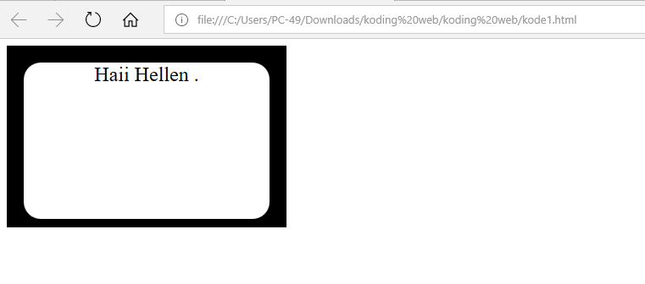

1. Source Code HTML

<!DOCTYPE html>

<html lang="en">

<head>

<title>Tugas 2</title>

<link rel="stylesheet" type="text/css" href="nomer2.css">

</head>

<body>

<div class="octagon">

<div class="teksnya">

Hellen Belinda G 201601038

</div>

</div>

</body>

</html>

Source Code CSS

.octagon {

width: 200px;

height: 155px;

background: rgb(8, 82, 167);

position: relative;

margin:0 auto;

}

.octagon .teksnya{

color: rgb(233, 53, 53);

padding-top : 15%;

margin: 10%;

text-align: justify;

}

.octagon:before {

content: "";

position: absolute;

top: 0;

left: 0;

border-bottom: 20px solid rgb(7, 185, 81);

border-left: 20px solid azure;

border-right: 20px solid azure;

width: 80%;

height: 0;

}

.octagon :after {

content: "";

position : absolute;

bottom : 0;

left: 0;

border-top: 20px solid rgb(115, 197, 47);

border-left: 20px solid azure;

border-right: 20px solid azure;

width: 80%;

height : 0;

}

Output:

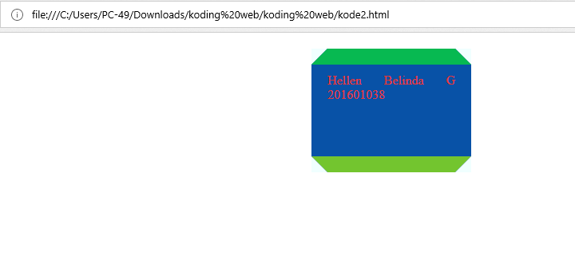

1. Source Code HTML
2. <!DOCTYPE html>
3. <html>
4. <head>
5. <title> Tugas 3</title>
6. </head>
7. <style>
8. .container {
9. width: 300px;
10. height: 200px;
11. margin: 0 auto;
12. background-image: repeating-linear-gradient(135deg, blue 0px,blue 15px, red 15px, red 25px,
13. orange 25px, orange 40px, white 40px, white 50px);
14. padding: 12px;
15. }
16. .container .inner {
17. background: white;
18. width: 300px;
19. height: 200px;
20. }
21. </style>
22. <body>
23. <div class="container">
24. <div class="inner">
25. dikirim dari Hellen Belinda G, Purwokerto.
26. </div>
27. </div>
28. </body>
29. </html>

Output:

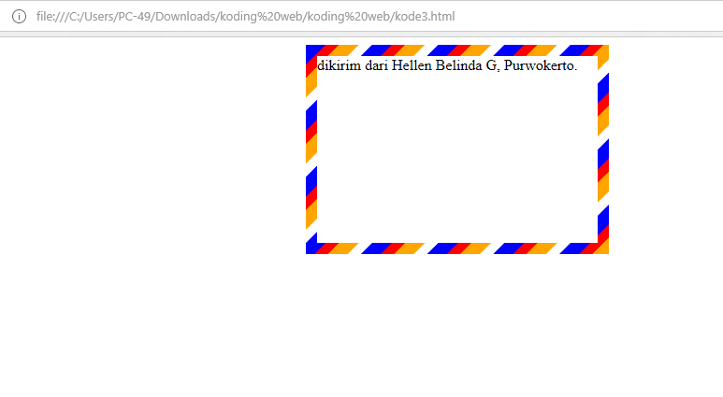

4. Source Code HTML

<!DOCTYPE html>

<html>

<head>

<meta name="viewport" content="width=device-width, initial-scale=2">

<style>

.parallelogram {

float: left; align: center; padding:10px; margin:5px;

width: 170px; height: 40px; transform: skew(25deg);

background: #d433ba;

}

.parallelogram2 {

float: left; align: center; padding:10px; margin:5px;

width: 190px; height: 40px; transform: skew(25deg);

background: #9c8794;

}

.tulisan {

font : 20px Arial red; align: center; margin:5px;

color : red; width: 150px; height: 15px;

transform: skew(-25deg);

}

.tulisan2 {

font : 20px Arial red; align: center; margin:5px;

color : red; width: 170px; height: 15px;

transform: skew(-25deg);

}

</style>

</head>

<body>

<div class="parallelogram" >

<div class="tulisan"> <B >Belinda</B>

</div>

</div>

<div class="parallelogram2">

<div class="tulisan"> <B>Belinda</B>

</div>

</div>

</body>

</html>

Output:

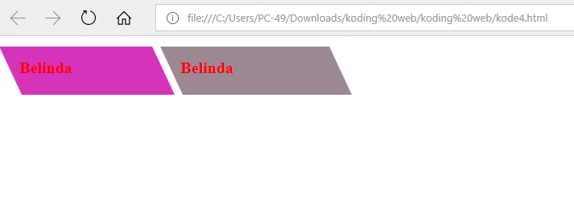

5. Source Code HTML

<html lang="en">

<head>

<title>kode5</title>

<link rel="stylesheet" type="text/css" href="nomer5.css">

</head>

<body>

<div class="diagram">

<div class="dig" style="background-color: inherit;transform: rotate(.2turn);"></div>

</div>

<div class="diagram">

<div class="dig" style="background-color: rgb(155, 233, 232);transform:rotate(.1turn);"></div>

</div>

</body>

</html>

Source Code CSS

.diagram{

float: left;

margin: 5px;

width: 100px;

height: 100px;

border-radius: 50%;

background-image: linear-gradient(to right, transparent 50%, rgb(221, 22, 145) 0);

}

.diagram .dig {

content: '';

display: block;

margin-left: 50%;

height: 100%;

border-radius: 0 100% 100% 0 / 50%;

transform-origin: left

}

Output:

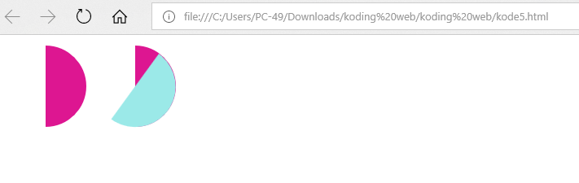

Membuat repository baru pada github

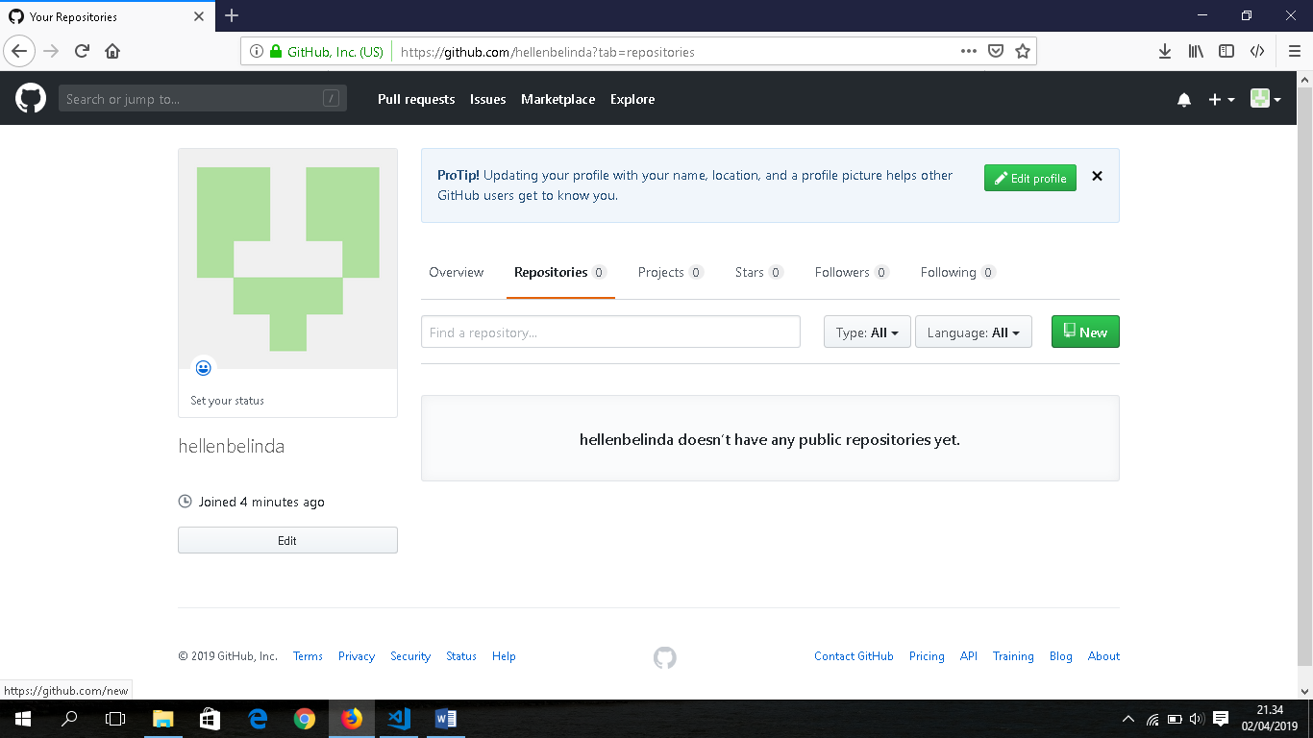

Beri nama Modul03 dan centang *initialize this repository with a README.* Kemudian pilih *Create repository.*

